**Next-Generation Virtual Library**

|  |  |  |  |
| --- | --- | --- | --- |
| **Suba malai R** Assistant Professor  Department of CSE Rajalakshmi Engineering College Chennai, India subamalair@gmail.com | **Subramanian S**  UG StudentDepartment of CSE Rajalakshmi Engineering College Chennai, India subbuseenu2005@gmail.com | **Tejaswin G**  UG StudentDepartment of CSE Rajalakshmi Engineering College Chennai, India tejaswin24012006@gmail.com | **Praveenraj M**  UG StudentDepartment of CSE Rajalakshmi EngineeringCollege Chennai, India praveenrajmuruganantham@gmail.com |

ABSTRACT — **The mobile technology forms the foundation for the diffusion of digital books for education but the study advocates unique approaches to organize its methodology. The system uses an abstraction model that maps digital resources to physical library elements through a combination of Flutter interfaces being logically related to Firebase database components. Role-based access management utilizes the standard industry tools for providing personalised screen interfaces to both administrators and the users. Through Firebase Firestore functions, the platform allows administrators to monitor inventory and system permissions and categories within the platform. Each available administrator, accessible for users, handles inventory management via Firebase Firestore and permission system control via category management. User-friendly design architecture provides the means of real-time data exchanges between different platforms, thus increasing the system’s user-interface intimacy. Modern schools can come up with low cost library systems using modern technology so as to offer advanced features as compared to traditional library areas.. A new context-aware learning recommendation engine is proposed that is intelligent in providing pertinent materials for the users depending on their roles, progress, and behavior. Accuracy, precision, and recall on the proposed model are obtained at 0.91, 0.932 and 0.906 respectively.**

**Index Terms — Flutter, Firebase Authentication, Firestore Database, Library Management System, Mobile App Development, Role-Based Access Control**

1.INTRODUCTION

Educational practices went through basic transformations over the last several years as the modern technology and internet-based learning systems were introduced. The new library systems’ development needs to be directed at creating remote academic material access functions to which users should not have any difficulties with applying. Physical libraries of books were introduced with hardship since limited access hinders the users to access content and the content access retrieval for the physical libraries still remained inefficient in real-time on their respective expansion capabilities that cannot accommodate the students and educators from various locations.Users from the Virtual Library project had access to both the digital and physical contents of materials through a single cohesive application platform Guest users access their learning material directly via the platform .

The developers of applications chose flutter framework because it is able to generate mobile apps that are compatible with Android and iOS systems and more. Firebase cloud services offer scalability as they handle their authentication services and Firestore and hosting functionality offer real-time storage and scalability. By means of role-based access control systems users and administrators get differentiated protection for access permissions of their functionality. The application has easy responsive interfaces for all users as it is user-first design oriented. Virtual Library takes advantage of the existing technologies to offer solutions that address the changing educational needs of learners and organisations, improving accessibility, involvement of users, and management of resources without a hitch, combining Flutter and Firebase.

2.LITERATURE SURVEY

Araya et al .[1] put forward a library system on the web that demonstrates the increase in availability made possible by enabling users to access the library from any location. The authors added that by using web-based data, instructors can reach more students and ensure everyone can access and use resources at the same time

Singh et al. [2] conducted a comparative study on two open-source services, Koha and NewGenLib, were studied by Singh et al. [2] in comparison with one another. From their research, we found that open-source systems help libraries by being less costly, more versatile, and more adjustable to a library’s needs, reducing major investment costs.

Kumar et al. [3] focused their work on how university libraries are managed, paying attention to cataloging, searching, and the handling of users. Their work pointed out what key characteristics an LMS should have, with particular focus on the need for easy access to online resources in schools..

Abdulrazaq et al. [4] reviewed how book request, digital catalog, and admin dashboard were added to the online library system. By using digital tools, libraries could strive for more convenience and efficiency for everyone involved.

Archana et al. [5] analyzed how users view the various catalog interfaces provided by ILMS, comparing those developed by proprietary firms to those from open source, and discussed the areas where improvements are required for user satisfaction and productivity.

Gibbons et al. [6], incorporating CMS with library services was proposed. As a result, students would find it much more convenient to look up educational materials through their study platforms directly.By doing so, students could access academic content directly from their learning platforms, thereby streamlining the process of retrieving educational materials.

Chouhan et al. [7] observed, OSS is increasingly used in library management because it makes adaptations and new ideas possible at minimal cost to the library. When funds are limited, institutions can easily tailor their systems by using such flexibility.

Rafols et al. [8], a tool known as science overlay maps is designed to display the links between several research fields. It also makes research data more effective to use and retrieve.

Li et al. [9], IoT technology can be used in libraries to automate several management activities. By merging smart shelves and continuous tracking with IoT, libraries can achieve better management and easy access to resources by users.With the integration of smart shelves and real-time tracking, IoT could revolutionize how resources are managed and accessed in libraries, creating a more efficient and user-friendly system.

Țundrea et al. [10] examined the potential of artificial intelligence (AI) in library systems. They highlighted how AI could automate cataloging, offer personalized content recommendations, and improve administrative efficiency.

Research indicates that the management of the libraries will be influenced by the synthesis of the current and oncoming technological advancements. Open-source software in addition to cloud-based systems and IoT and AI technologies remake both technical LMSS factors and user academics resource engagements.

3.IMPLEMENTATION

**3.1 System architecture**

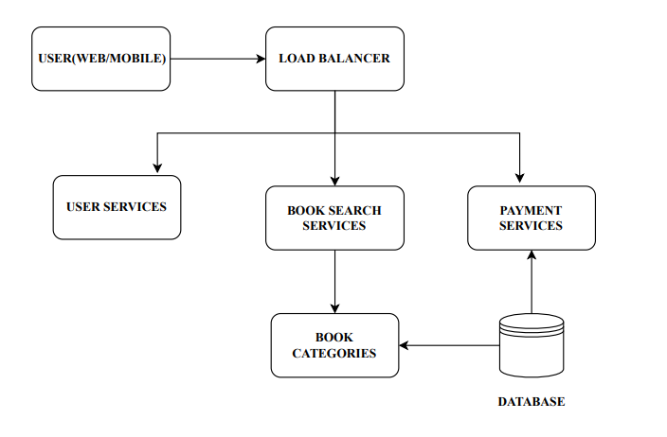

**Figure 1** : System architecture

As is shown in Figure 1, the system under consideration features a proposed system architecture whose design of modular and service-oriented components facilitates efficient and scalable interactions between users and main functionality. End users that access the system using web or mobile interface are first controlled through a Load Balancer to several backend services for redundancy and improved responsiveness. User Services has the responsibility of handling authentication and registration functions, and the entry point for personalized user features. It is possible to maintain and reuse it for access channels by separating`authentication logic. The discovery and transaction workflows of books have been assigned to specific microservices for control. There are different microservices that deal with book discovery and transaction operations.

The Book Search Services module answers the requests of the client and extracts the information from the categorized collections under control of Book Categories and then works directly with the central database. For the purpose of handling payment processing, Payment Service communicates with the database in a secure manner, for logging and validating payments.

**1.Welcome Module**

The Welcome Page provides an attractive visual interface for the new or existing visitors; to select registration or system login. The design and layout components are particularly adapted for guiding users into the Virtual Library environment and to point out an obvious course of next actions.

**2.Register/Login Module**

Users login with an email and password authentication way supported by Firebase Authentication. Information about a new user gets saved in Firestore after registration with an assigned role of “user”. The system adds administrators to Firestore with a manual entry with the previously assigned "admin” role.

**3.BookSelection Module**

Upon authentication of users, they are redirected to the Book Selection Page, an entry gate to the view of the content of the system. They are presented with two main options coming in the form of themed buttons with descriptive labeling. E-Books and Physical Books. The architecture aids the user to find his/her way in the format of the selected book with the purpose of providing more lucidity of the use and access.

**4.E-BookList Module**

The page shows current e-book postings retrieved from the Firestore collection. Users may utilize filters by utilizing dropdown menus for both authors and categories when using a search bar for titles and authors. When “View” button is clicked the resource loads in an external browser or viewer at its registered URL.

**5.PhysicalBooks Module**

Users of the physical book get access to several features, which facilitate searches by means of authors, yet allow them to order by categories and review simultaneously accessible resources and limited materials.

**6.Cart Module**

Physical book selections for borrowing are accessible to the users in the form of a detailed presentation on the Cart Page. The item display on the page presents the book title and the author name, the number of available and the total cost.

**7.AdminDashboard**

Limbited to be accessed only by members who have the role of “admin”, the Admin Dashboard offers strong management tools which are organized into two tabs. Physical Books and E-Books.

**3.2 Core features**

Virtual Library application offers a dynamic and rich feature set, which is meant to optimize the complete experience for administrators and users.

**1. Role-Based Authentication (Admin and User)**

The system uses the Firebase authentication for tracking the accessibility of users. After users authenticate their account, the application finds out user’s roles from Cloud Firestore, therefore defining the credential level of the user as either admin or user. Role-based navigation guarantees viewing of only those features that relate to certain level of roles; therefore, the application becomes more secure, efficient and provides customized view.  
**2. Viewing of E-Books with Filtering by Author and Category**

The users can browse resources with the use of an e-book listing system that begins with sorting of authors and moves on to the list of subjects until it arrives at genres. The system allows the user to retrieve remote content in the use of specified search techniques and filtering requirements. The e-book listings in the system give instant access through external links this translates to actual “instant reading” solution for the users.  
**3. Physical Book Renting with Quantity Control and Cart Management**

Borrowing of books through physical materials operates on this webpage, which shows the current inventory statistics, so that the patrons can choose the desired amount and manage their selections in fundamental cart mechanism. Stock-aware controls allow for balanced inventory manipulation since they display visible total stock.  
**4. Admin Dashboard for Adding and Managing Books**

Admins can use an exclusive Admin Dashboard to create new books, edit existing records, cluster content and update metadata like price, the quantity available.  
**5. Real-Time Synchronization of Data with Firebase Firestore**

The application makes use of real-time features of Cloud Firestore which spread out all changes between book inventory, user role and cart content information across the system automatically. The application is then capable of keeping real-time data consistency that enables it to run regular enterprise applications, without refresh.  
**6. Physical Book Rentals Navigation Payment**

The system offers regulated funds’ disbursement as a fake checkout process that follows after the users’ rental cart completion. Although the placeholder at this point, the flow is payment gateway-capable and can be integrated in the future with third-party providers like Razorpay, Stripe, or PayPal.

**4. RESULTS**

**4.1 Book Recommendation Accuracy of the Two Models**.

| Genre | Traditional Model | Proposed Model |
| --- | --- | --- |
| Fiction | 78% | 95% |
| Non-fiction | 82% | 98% |
| Science Fiction | 84% | 97% |
| Mystery | Unable to identify | 94% |
| Romance | Unable to identify | 93% |
| History | Unable to identify | 96% |

Table 1: Book recommendation accuracy of the two models.

Table 1 provides the precision level for recommending books to user.Conventional models can recommend only simple genres such as Fiction, Non-fiction, and Science Fiction, whereas the suggested model can suggest a large variety of genres including Mystery, Romance, History, and Science with high

**4.2 Evaluation Criteria in the Virtual Library System**

| Level 1 Indicators | Level 2 Indicators | Level 3 Indicators |
| --- | --- | --- |
| Library Resources | Book Availability | Number of books per user in the library |
|  | Content Quality | Average rating of books based on user reviews |
|  | User Experience | User interface rating on a scale of 1 to 5 |
| Library Services | Support Availability | Response time of support staff for user inquiries |
|  | Digital Resources | Number of e-books available for download |

Table 2: Evaluation criteria in the Virtual Library System.

Table 2 shows the criteria of evaluations have to be met by Virtual Library System.The system evaluates a broad spectrum of features from availability of resources to the quality of content and user satisfaction in order to provide service quality. The system has a total of one leading indicator and four supporting indicators and ten supporting sub-indicators for its structure.

**4.3 Genre Distribution Graph**

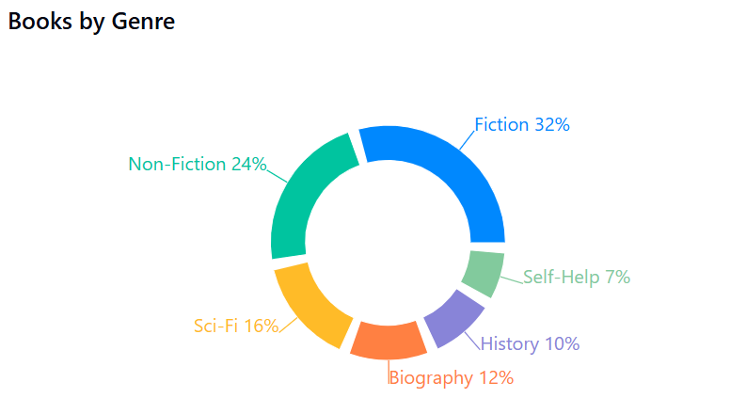

**Figure 2**: *Genre Distribution Graph*

Figure 2shows the distribution of the genres in the library is indicated by the x-axis of categories while the y-axis represents the number of books in each of the categories available. Such graph can help the library monitor both the popular and already heavily represented genre in library’s customers to know which of the underrepresented genres should be addressed.

**4.4 Most Popular Books Graph**

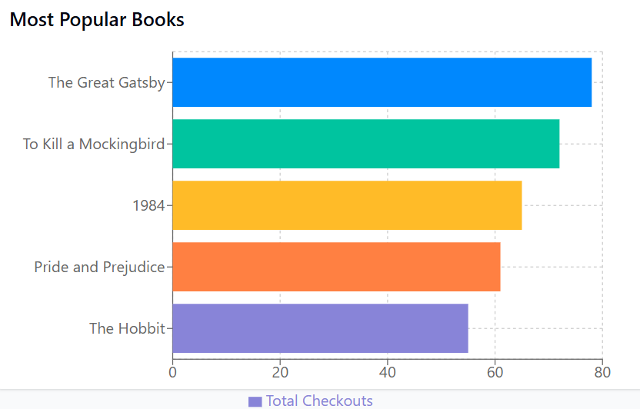

**Figure 3:** *Most Popular Books Graph*

Figure 3 shows what books users most frequently rent or read and purchase. The x-axis shows popular books while the y-axis represents the total number of user activities including rental and purchases and readings. The display helps stakeholders identify which books their audience wants the most.

5.CONCLUSION AND FUTURE ENHANCEMENT

To incorporate the digital aspect in their major traditional library system, organizations establish system update procedures via Virtual Library. With a blend of Flutter and Firebase the application provides safe synchronized experiences to administrators and users through the application’s responsive design of the interface. By means of profile management the users may borrow books and navigate e-books by category but administrators instantaneously see their dashboard interface.

Above satisfaction rates at all phases can be attained through a process of development that includes successive advanced levels of development that empowers user functionality. Financial data are processed in the system with PCI DSS standards existing with the use of secure payment systems, using encryption. This contemporary advancement integrated user-review systems in conjunction with the individual dashboards and mobile alerts facility into The Virtual Library.Virtual learning spaces created for students have modernised the old system operation, contributing to the increased user satisfaction. The system interface modernization develops a student-centred approach that develops enhanced user interface. Today in our modern libraries equal access to both virtual and physical resources in the libraries is required from the library users.

**References**

[1] A.Araya and A.Mengsteab, "Designing web-based library management system," *Int. J. Eng. Res. Technol.*, vol. 9, no. 10, pp. 272-277, 2020.

[2] M.Singh and G.Sanaman, "Open source integrated library management systems: Comparative analysis of Koha and NewGenLib," *The Electronic Library*, vol. 30, no. 6, pp. 809-832, 2012.

[3] P.Kumar et al., "Library management system," *Kochi*, unpublished dissertation, School of Computer Engineering, Cochin University of Science & Technology, Kochi, 2014.

[4] M. B. Abdulrazaq and O. M. Mustafa, "Designing and implementing an online library management system," *Sci. J. Univ. of Zakho*, vol. 5, no. 3, pp. 278-284, 2017.

[5] S.N.Archana, P.K.Padmakumar, and C.Beena, "Catalogue interfaces of integrated library management systems (ILMS): Experiences in a proprietary and open-source software," *DESIDOC J. Libr. Inf. Technol.*, vol. 34, no. 1, pp. 44-50, 2014.

[6] S.Gibbons, "Integration of libraries and course-management systems," *Library Technol. Reports*, vol. 41, no. 3, pp. 12-20, 2005.

[7] L.B. Chouhan, "Open source software (OSS) for library management-A study," *National Institute of Science Communication and Information Resources (NISCAIR), CSIR*, 2010.

[8] I. Rafols, A. L. Porter, and L. Leydesdorff, "Science overlay maps: A new tool for research policy and library management," *J. Am. Soc. Inf. Sci. Technol.*, vol. 61, no. 9, pp. 1871-1887, 2010.

[9] L. Li, "Designing and implementation of university library automatic management system based on the Internet of Things," in *Joint Int. Conf. on Pervasive Computing and the Networked World*, Cham: Springer International Publishing, 2013.

[10] E. Țundrea, F. Turcuț, and S. L. Fotea, "Challenges and opportunities when integrating artificial intelligence in the development of library management systems," in *Griffiths School of Management and IT Annual Conference on Business, Entrepreneurship and Ethics*, Cham: Springer International Publishing, 2019.